UniChat - Everything You Need

Phase 1 Report - User and Task Analysis



**Group 06**

Igor Diniz - UP 202000162

João Pinheiro - UP 202008133

Ricardo Cavalheiro - UP 202005103

# Project Description

The goal of our project is to create an application designed to make it easier for students to communicate among them giving them a better academic experience.

Users must first authenticate using their sigarra account information. The platform will have different rooms that students are divided into based on their subjects which allows students of the same class to get to know each other and to talk about specific subject information such as the division of students into group projects or to discuss topics learned in class.

Users can also view other students’ details in particular age, year of graduation, nationality, and region. Our goal is to create a better environment for every student.

# Related apps, services or systems

There are some apps and systems that wrap some features described in the above section, for instance:



1. Whatsapp
2. Messenger
3. Agenda Cultural do Porto
4. Discord

# Questionnaire Highlights

From the responses to the questionnaire, we were able to identify the following insights:

1. 52.2% of students had problems with the initial adjustment to college.
2. 52.2% of students are not entirely satisfied with their academic cycle so far.
3. 21.7% of students are not sure if they are in the right course for them or are considering changing areas.
4. 26.1% of students do not have a clear idea of ​​what to do after finishing the current cycle of studies.
5. 70% of students use social media more than 3 hours per day.
6. The social media most used by students are Instagram, Youtube, Whatsapp, Tiktok, and Twitter.
7. 78.3% of students have no difficulty adapting to new social media.
8. What bothers students most on social media are unverified offensive comments
9. 65.2% of students think that social media have been a great benefit in people's lives.

Answers to 11 questions

## Who are the users?

Our customers are students, from Porto University, with an age gap of 18-23. These students got their adolescence marked by the covid and now face the consequences. They belong to a generation that is destined to thrive.

## What tasks do they perform?

Our users are very talented. From sports to student associations, from academic groups to organizing school trips. A few minorities also work while studying and most of them want to still study after finishing their bachelor's degree.

## What tasks are desirable?

Many students complain about offensive comments on social media. So, it would be ideal to have a way for the student to block or delete comments of this type. In addition, a large percentage of students feel undecided about what to do after graduation. Therefore, it would be interesting to have a place to discuss ideas and suggestions within our application, so that some could help each other with tips, like a forum. Students also will be able to create groups in the platform, talk with each other by text messenger or by video call, and attach/detach groups.

## How are tasks learned?

As our project should focus on the users and their usability, and most of the users are young students who have no problems with the adaptability of a new social media, the tasks would be learned by the experience using the platform. They will be intuitive to learn but will have a guide for beginners when the user accesses the platform at first. Therefore, no previous knowledge is required.

## Where are tasks performed?

A technology device with an internet connection is the only tool a customer needs to use our product.

## What is the relationship between the user and information?

One of the biggest goals of the project is to help the students to have access to useful information, in the academic field. So, sharing information is extremely important to engage the community of students. Students can see personal information about other students, such as age, year of graduation, nationality, and region. Although, confidential information will never be shared, without the consent of the user. There will be a channel where students are going to be able to share information regarding what to do after finishing their cycle of studies.

## 

## What other instruments does the user have?

Nothing, so far.

## How do users communicate?

Users will be chatting through our dedicated chatting tab. There will be group chats divided by year, class, curricular unit, and personalized groups by the user.

## How often tasks are performed?

* Video meeting to discuss academic projects - OFTEN
* Chat with the classroom - ALWAYS
* Share interesting information (like a forum) - OFTEN
* Divide students into groups - OFTEN
* Block messages - HARDLY EVER

## Are there time restrictions?

Users are allowed to use our app at any time they want. It should be available 24h a day.

## What happens if something goes wrong?

Students can send an email to the tech support responsible for the maintainability of the platform.

# Personas

Two personas were created based on the responses to the questionnaire.

The first one is João Lopes, a 25 years old working student from Porto who enjoys socializing and is optimistic about his future.

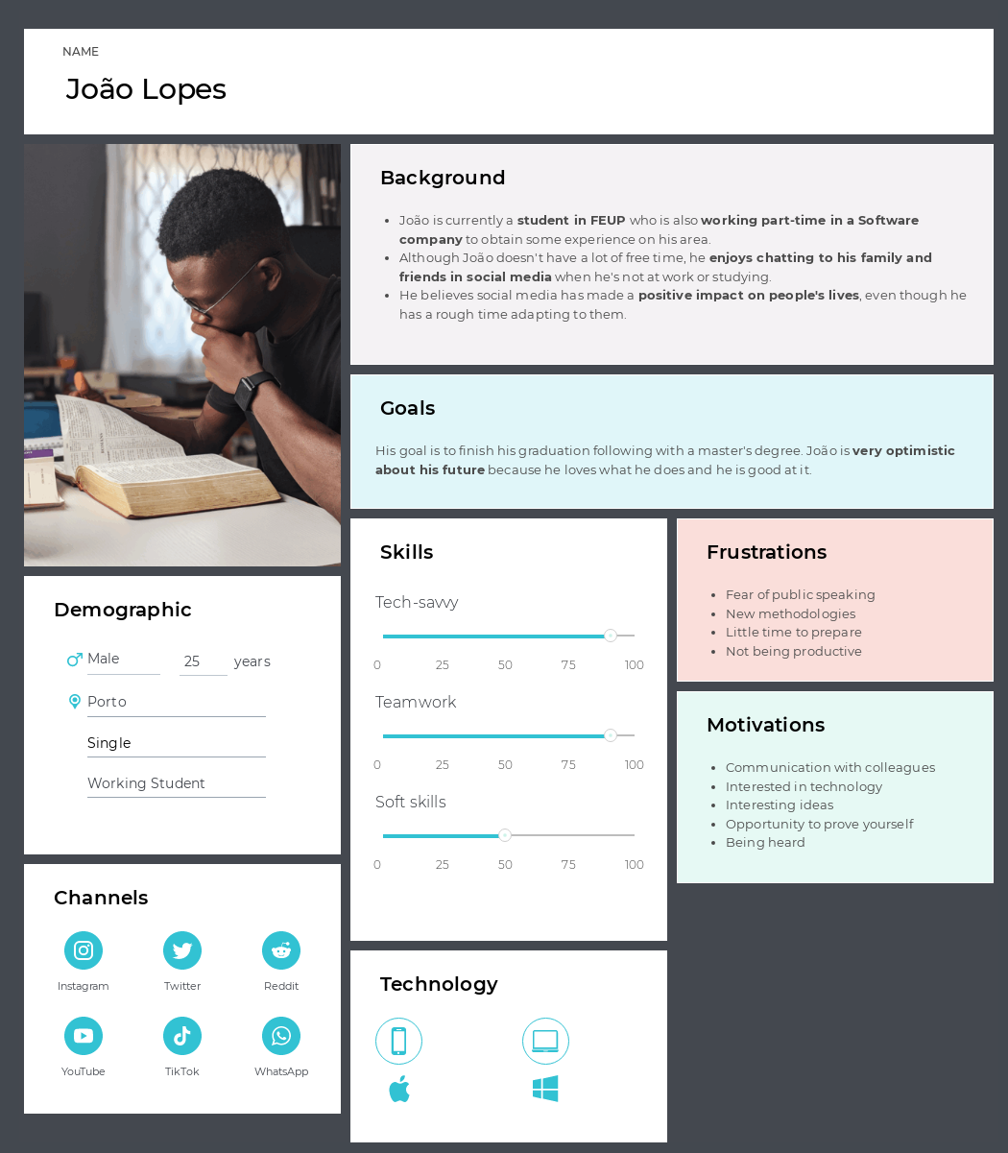

The second one is Diana Lopes

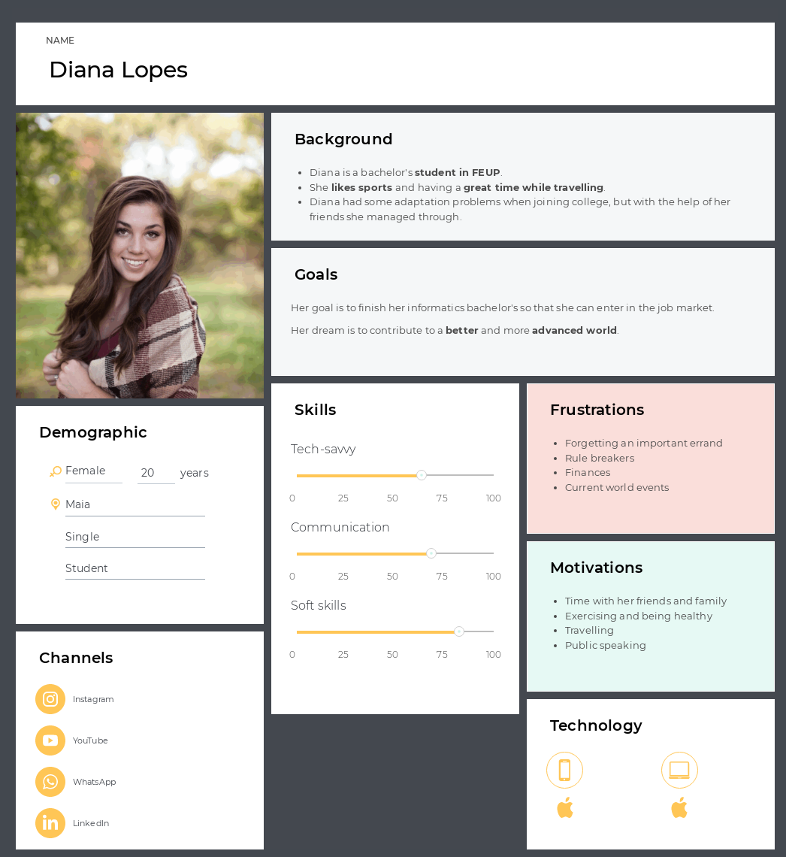

# Activity Scenarios

After getting responses from the questionnaires and identifying the two main personas, we created two different activities whose descriptions are the following:

## João Lopes

João is just preparing for the start of the new academic year. When preparing his backpack, João grabbed his phone to check what he needed for the next day in class. He wasn’t sure about the material so he wanted to chat with his colleagues. He opened **UniChat**, authenticated with his sigarra log-in, and went to the 2nd year group chat. There he sent a message asking what classes they would have the next day and the material needed.

A colleague, Gustavo, answered him with a photo of his backpack full of the material needed for the next day. João reacted with an emoji and went to prepare his backpack to start the semester.

## 2. Diana Lopes

Diana just arrived home after a long and rough day at university. After realizing that she was confused about the topics learned in class she decided to open **UniChat** and talk to her colleagues hoping someone would clarify the subject. Several students also expressed some doubts about it. Lara, who was very attentive in class, managed to explain and clarify with her colleagues about the topics and everyone was grateful. They recognized that with mutual help the academic experience is much more enjoyable and easier.

# 

# 

# 

# 

# Simplified Conceptual Model

## Objects (attributes)

* + User (name, nationality, region, age, role)
    - role = student | teacher
  + message (date, sender, type)
    - type = photo | document | text
  + group chat (date of creation, users)
  + video call (date, duration, users)
  + event (local, date)
  + archive (group)

## Actions

* + Send, edit, remove message
  + join, leave, cre;ate, share group chat
  + archive and unarchive group chat
  + start, join, end video call
  + edit, remove profile information
  + create, edit, remove, show interest in event
  + view other users information

## Relations between

* + User can send messages
  + messages have one author
  + group chat has users
  + group chat has messages
  + video call involves 2 or more users
  + an event has interested users
  + users can be interested in events
  + the archive has group chats

# 

# 

# 

# 

# Functionalities and tasks

# The app should enable the user to:

* Logging in
* Manage message
  + Send text message
  + Send image
  + Send file
  + Edit message
  + Delete message
* Search
  + For messages
  + For colleagues
* Sharing
  + Invite people to group chat
  + Invite people to an event
* Interaction between users
  + Video calls
  + Answering to messages
  + Reacting to messages
* Manage events
  + Create
  + Edit information
  + Remove
  + Show interest in
* Manage group chat
  + Create group chat
  + Add members
  + Remove members
  + Archive group chat

# 

# 

# Usability Requirements

* **Send a text message to a colleague**
  + **Efficacy:**

All users completed the task, 95% didn't made more than 2 errors.

* + **Efficiency:**

Average time under 20 seconds, 90% made less than 5 clicks

* + **Satisfaction:**

Below 2% dissatisfied, 98% preferred our solution.

* **Add a member to a group chat**
  + **Efficacy:**

All users completed the task without any hint, 90% made less than 3 errors.

* + **Efficiency:**

Average time under 1 minute, the task was completed in less than 10 clicks.

* + **Satisfaction:**

Intuitive task, users showed ease in completing the task.

* **Show interest in event**
  + **Efficacy:**

Users completed the task, 80% made less than 2 errors.

* + **Efficiency:**

Average time under 1 minute, task completed with an average of 10 clicks.

.**Satisfaction:**

The task was easy to learn and complete.

# 

# 

# 

# 

# 

# Conclusions

We realized through research that our app would be useful for FEUP students, mainly in the initial adaptation phase, which is the most difficult period for them.

Other than that, after analyzing the survey, we can expect ease of use of our application, as it will be intuitive like the other social media that students have already used.

Finally, UniChat would also be important for students who are attending the latest year of the studying cycle to discuss the possibilities of what may be done after the degree or master's degree, since the research has shown a significant amount of undecided.

# 

# 

sd

d

d

d

# Annexes

## Screenshots

### Figure 1. Adaption difficulty

### Figure 2. Success of academic cycle

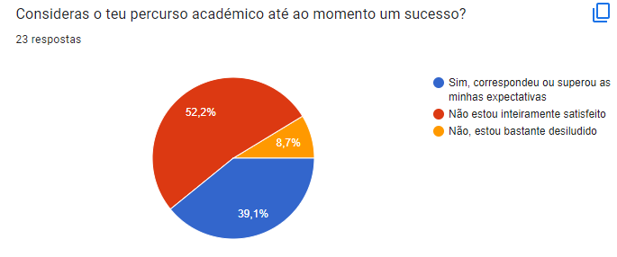

### Figure 3. Satisfaction with the course

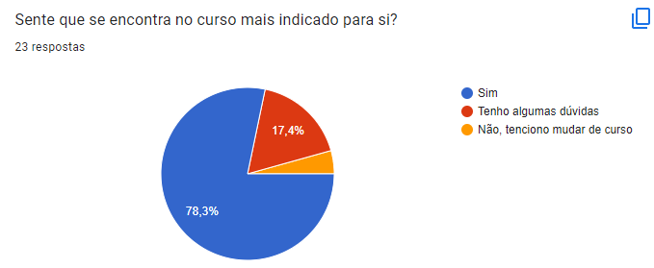

### Figure 4. What to do after finishing the bachelor

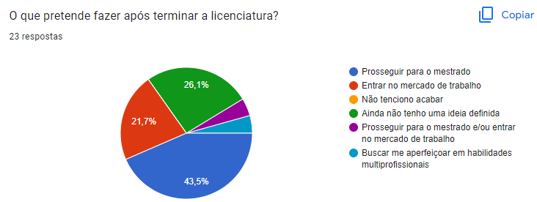

### Figure 5. Social media usage

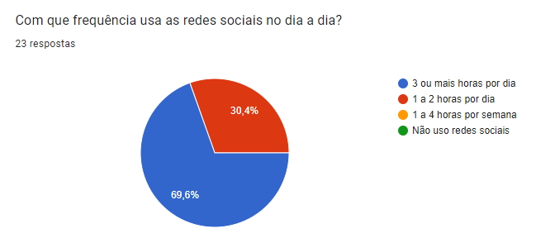

### 

### Figure 6. Adaptability of a new social media

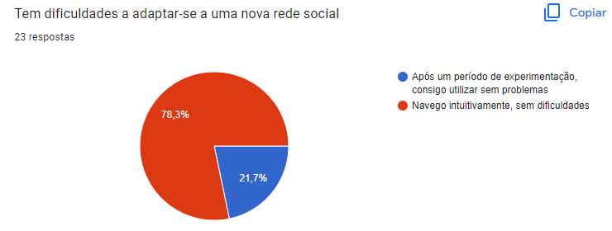

### Figure 7. Impact of social media

